**JUSTICE ANNUAL GENERAL MEETING**

**Wednesday 8 November 2023**

**Registration from 5pm, meeting starts at 5.30pm**

**TO BE HELD VIA ZOOM** [**https://us06web.zoom.us/j/87102916040**](https://us06web.zoom.us/j/87102916040)

**Meeting ID: 871 0291 6040 Passcode: 014757**

***For any technical support on the day please contact:***

***Josie Williams 07713 868 980*** [***jwilliams@justice.org.uk***](mailto:jwilliams@justice.org.uk)

***Samantha Burridge 07949 768 308*** [***sburridge@justice.org.uk***](mailto:sburridge@justice.org.uk)

Contents

How to download the Zoom app 1

How to join the meeting through the link 2

How to join the meeting through the Zoom app 3

How to join the Zoom call via phone 5

Once you are in the meeting 5

PC view: 5

Tablet view: 5

Phone view: 7

How to ask a question 7

Asking a question by speaking at the meeting: 8

Asking a question using the chat function: 11

How to vote 15

How to join the lecture 16

Participants can join the meeting via internet browser, the Zoom app or by dialling in. Instructions for each of these are below.

For the best user experience, it is recommended that you join on a tablet, PC or laptop rather than the mobile phone app, as you may not be able to see all of the other participants.

# How to download the Zoom app

Ensure you have Zoom downloaded to avoid any delays on the evening.

You will need to go to the application store that your device supports.

App Store (apple users): <https://apps.apple.com/us/app/id546505307>

Google Play store: <https://play.google.com/store/apps/details?id=us.zoom.videomeetings>

If you are on a Windows supported machine you can download it here: <https://zoom.us/support/download>

Hit the download/install button. It may ask you for your password for your App Store/Google Play Store account. If so, enter that. Once downloaded you can open Zoom up.

# How to join the meeting through the link

Click on the joining link: <https://us06web.zoom.us/j/87102916040>

If you are on a laptop/PC it will take you to a webpage, which will ask you to open zoom meetings – it may also automatically open! If it doesn’t, click “open zoom meetings”.

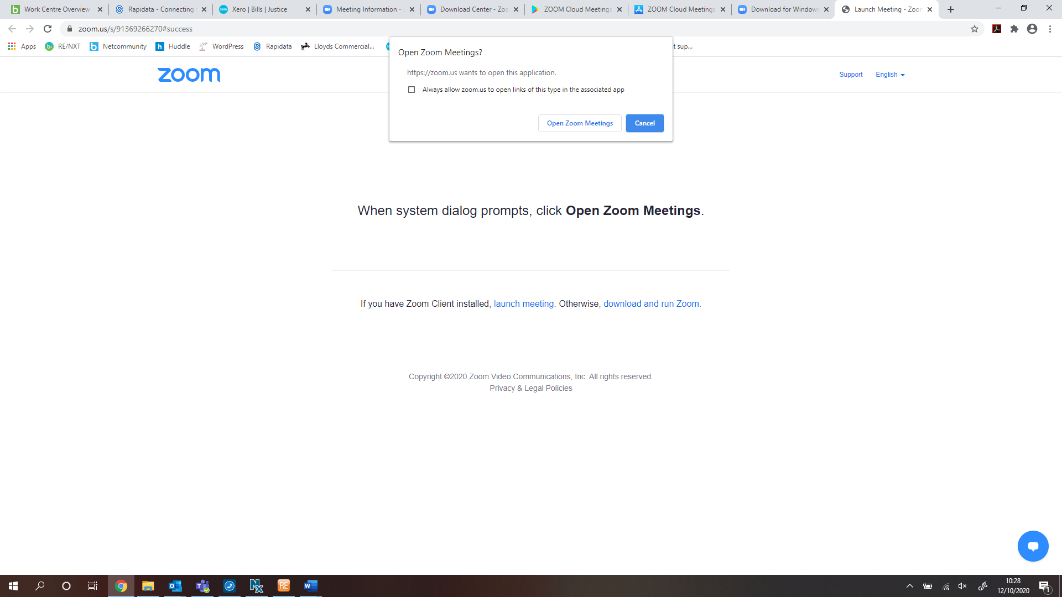

A box may pop up to ask you to join with computer audio. If it does, click this and then you will be able to join the meeting.

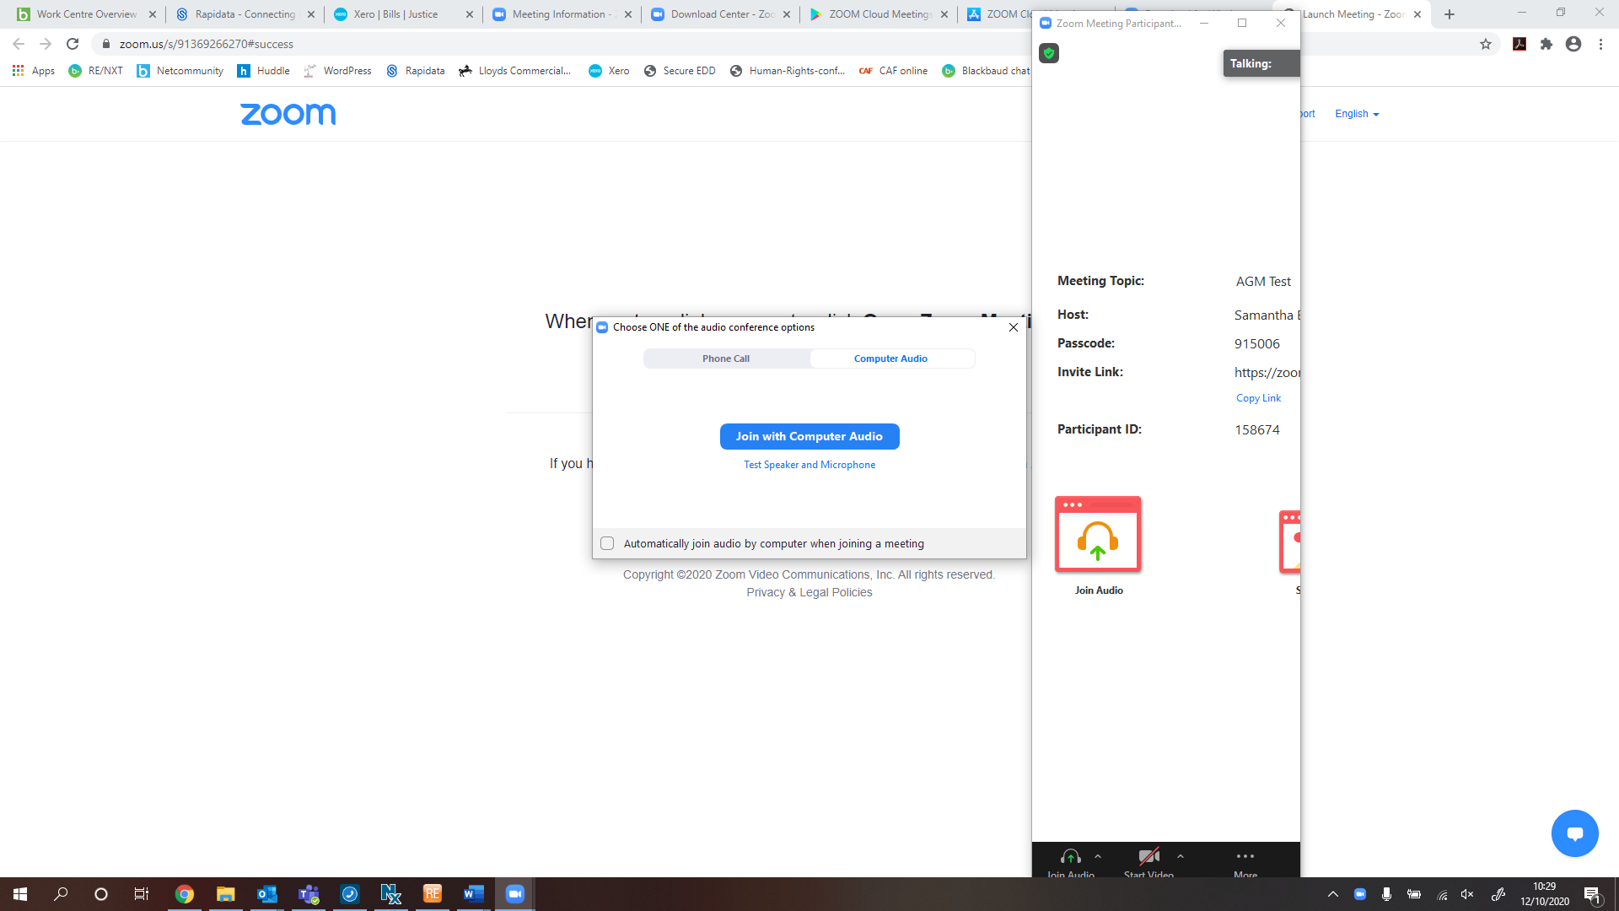

If you are early and the meeting has not been started yet it will look like this.

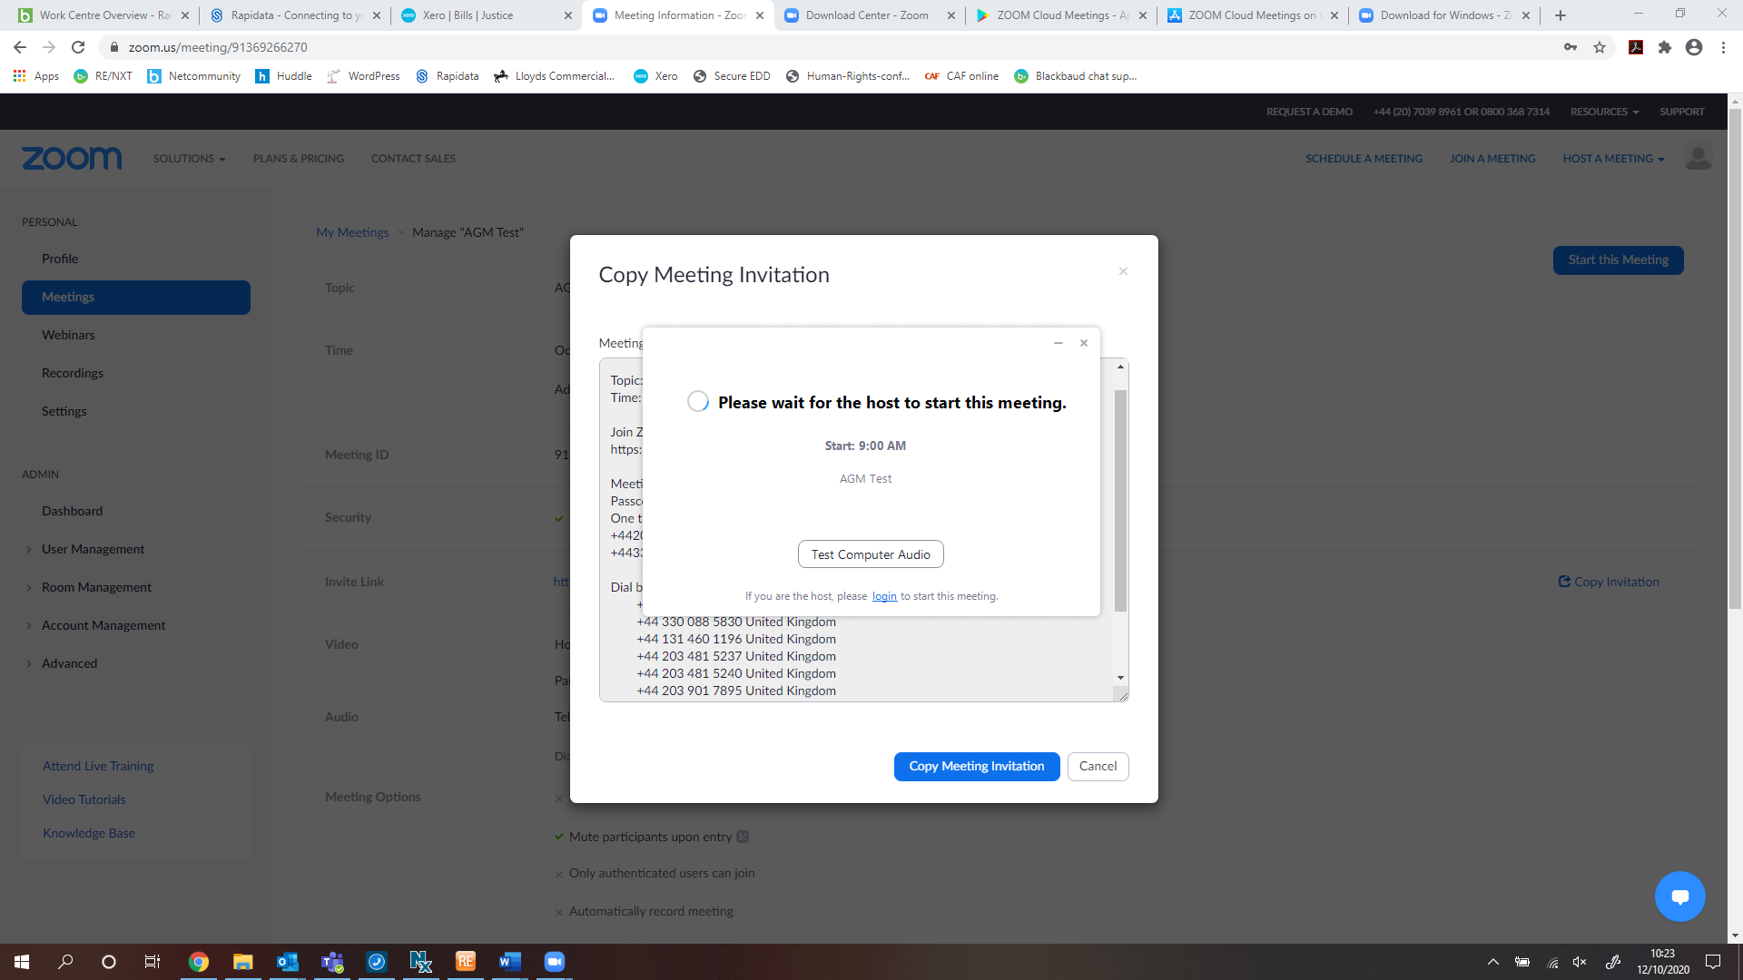

If you are on a phone/tablet, click on the link and it will open the zoom app. It will ask you for the meeting password: **014757**. Enter this and click “continue”.

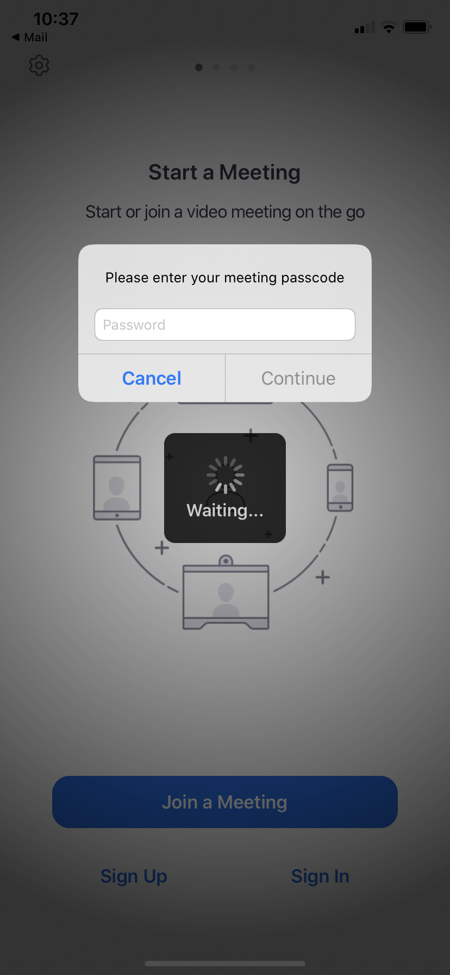

It will also ask if you want to join with or without video.

If you are early and the meeting has not been started yet it will look like this.

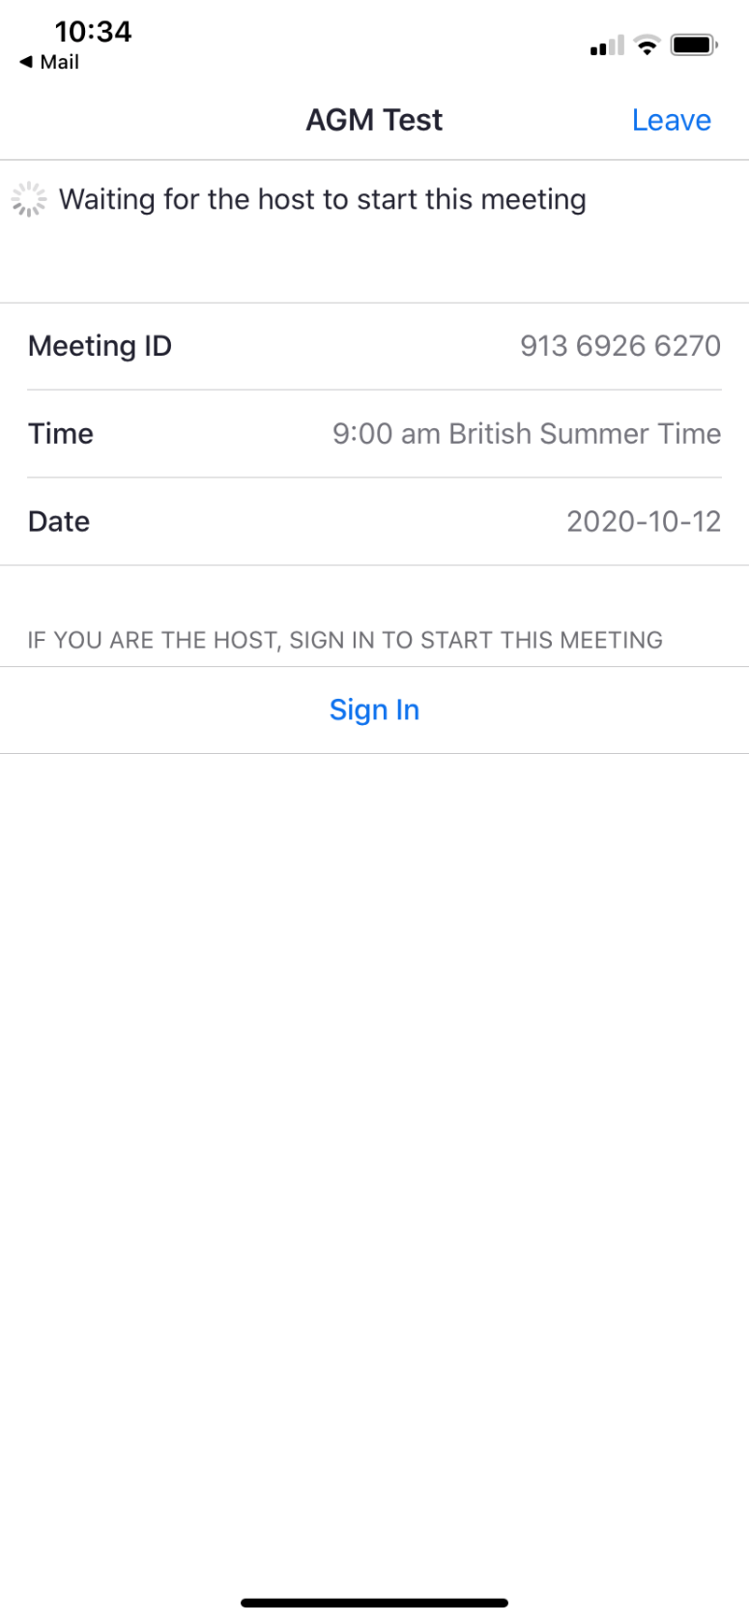

Otherwise you will receive a message saying ‘waiting for the host to admit you to the meeting’.

# How to join the meeting through the Zoom app

Click join a meeting.

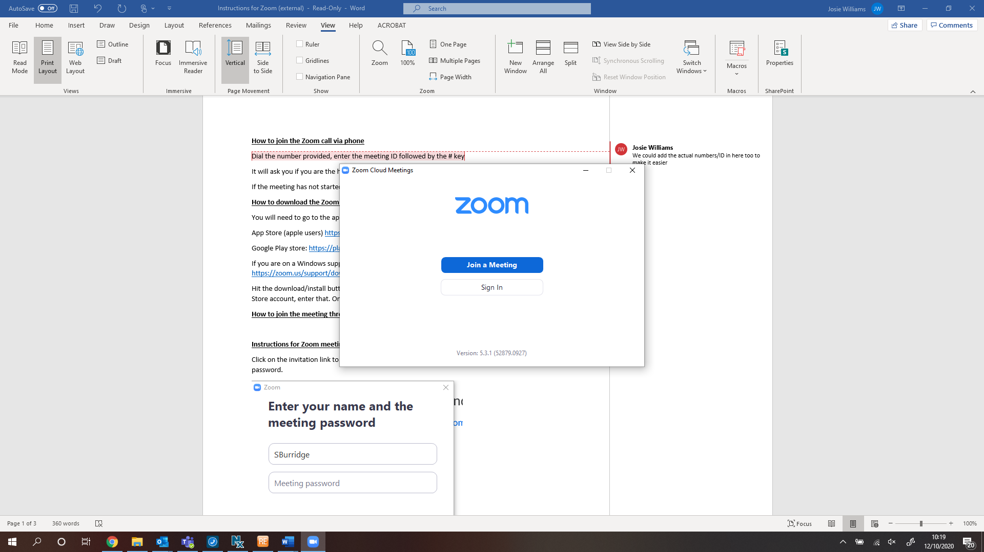

Enter the Meeting ID **871 0291 6040** and your name.

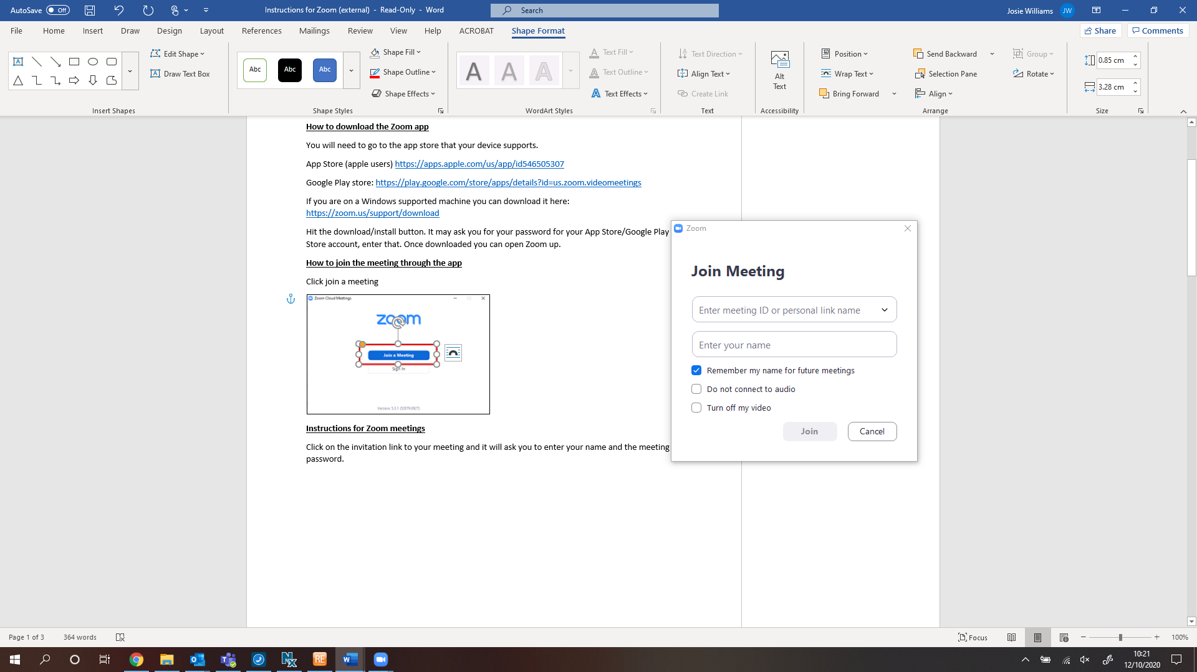

Enter the password **014757** for the meeting.

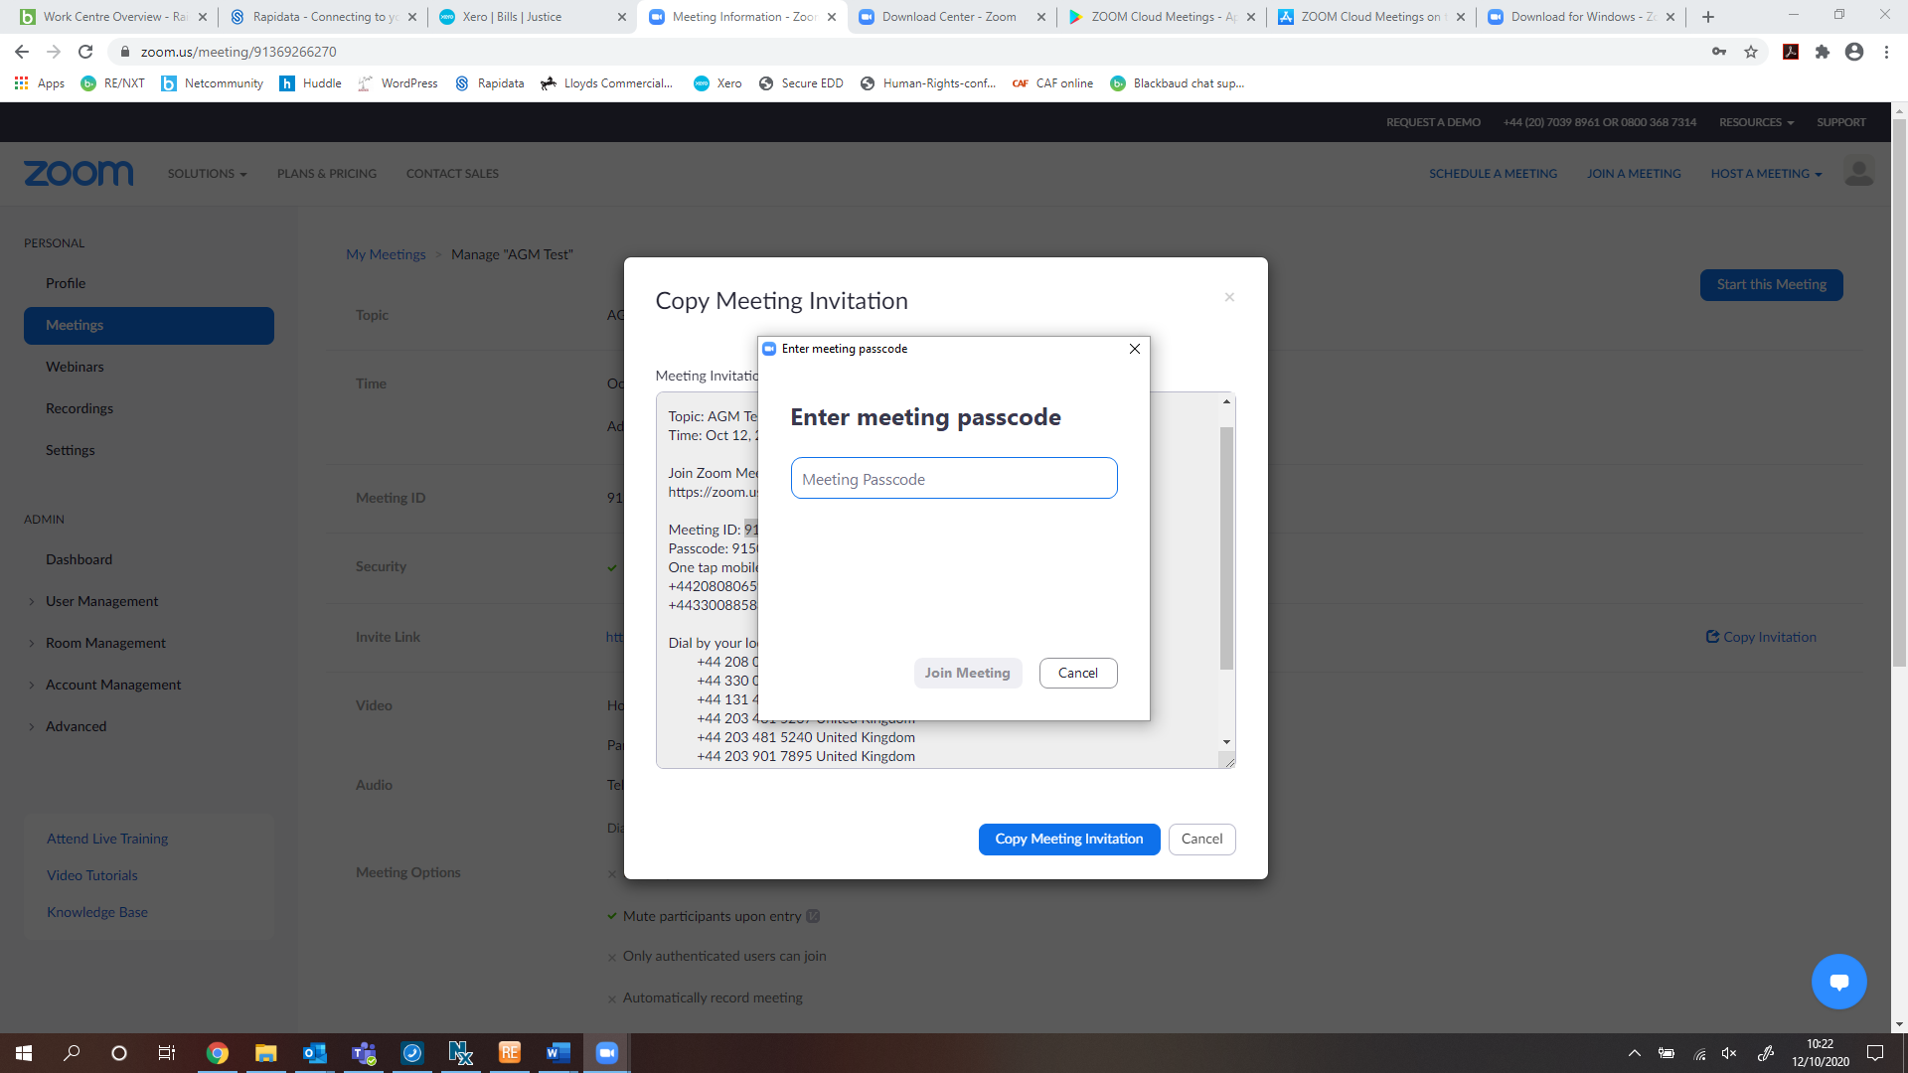

If you are early and the meeting has not been started yet it will look like this:



Otherwise you will receive a message saying ‘waiting for the host to admit you to the meeting’.

# How to join the Zoom call via phone

Dial the number: **+44 208 080 6591** provided, enter the meeting ID: **871 0291 6040** followed by the **#** key.

It will ask you if you are the host or participant. You are the participant so enter the **#** key.

If the meeting has not started yet, you will just need to wait until it does.

# Once you are in the meeting

## PC view:

Along the bottom, you can mute/unmute & turn video on or off.

To avoid audio feedback please mute your microphone unless you are speaking. There will be opportunities for questions during the meeting and if you wish to do so, you will need to unmute your microphone or use the chat function box (details below).

If you would like to change the view of the screen, click view in the top right-hand corner. You can change it to gallery view (to see all participants) or speaker view (so that just the person speaking is displayed).

If you click on “chat” and/or “participants” it will open this up in the right-hand side. You can view who is participating in the meeting and you can also send messages in the chat-box. There is the option to send a message to everyone, or just to individual attendees. This is where will ask participants to ask questions if they do not wish to speak at the meeting.

To exit the call, select “leave” which is in red at the bottom right-hand side.

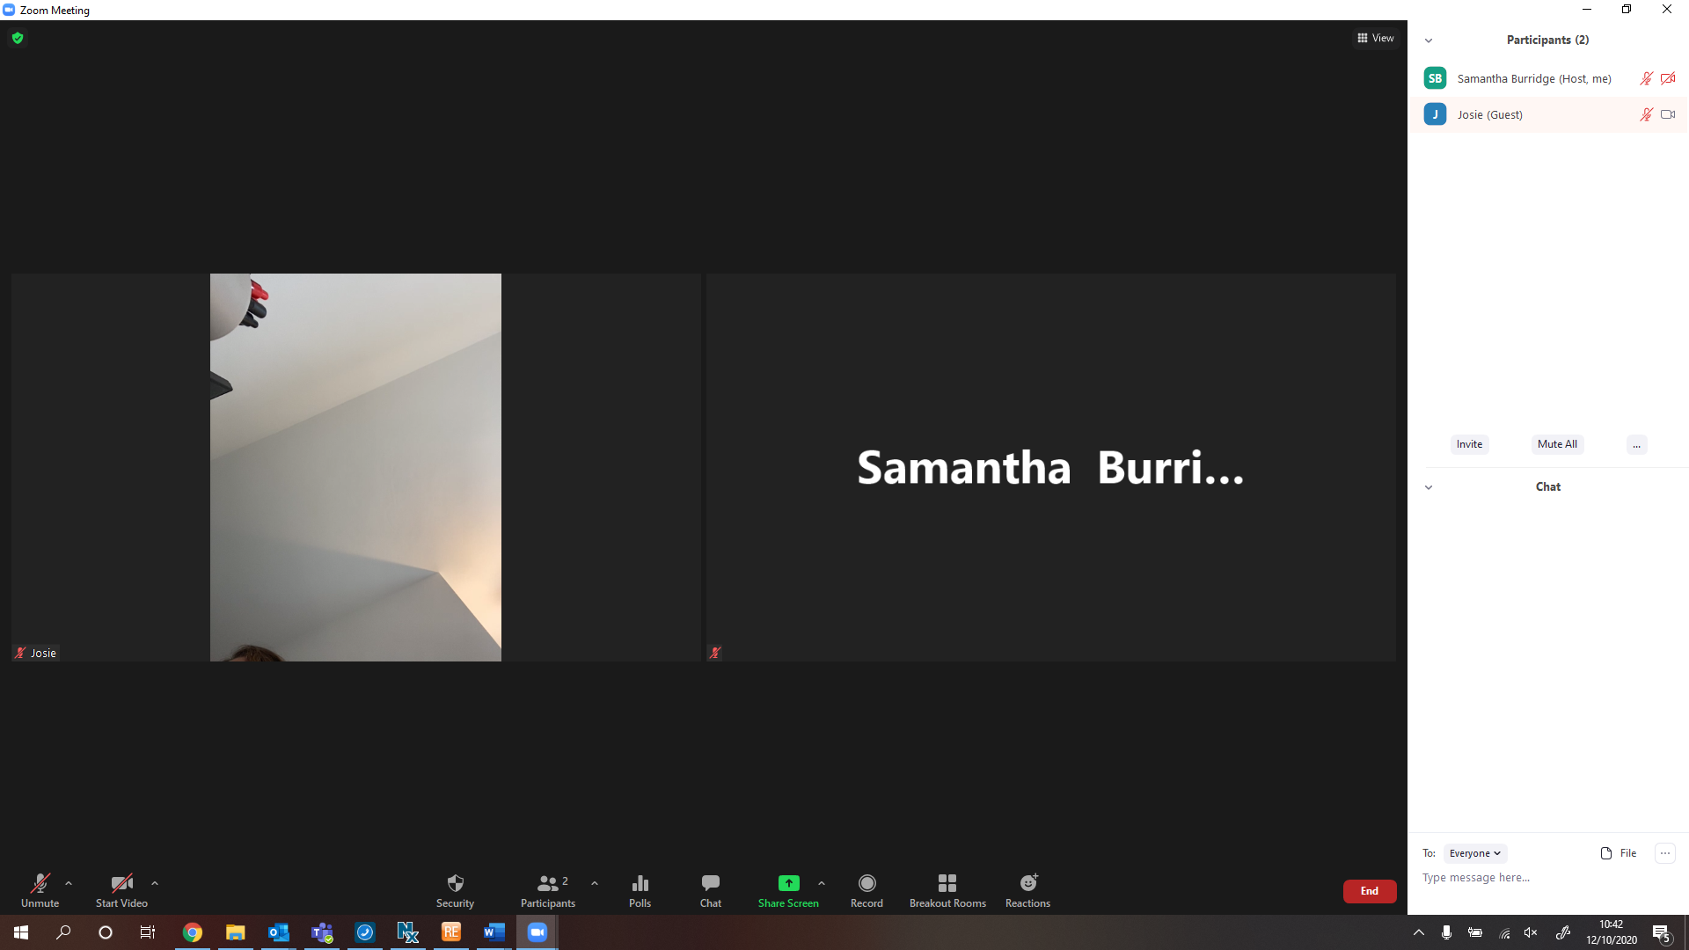

## Tablet view:

If you join via tablet you can either choose speaker (the default) or gallery view (where you can see other participants on the screen) You will need to swipe across to additional screens to see all participants, depending on the number attending.

To mute/unmute or show your video/hide your video you should click on the options at the top of your screen.

To exit the call, just select “End / Leave,” which is in red at the top left-hand side.

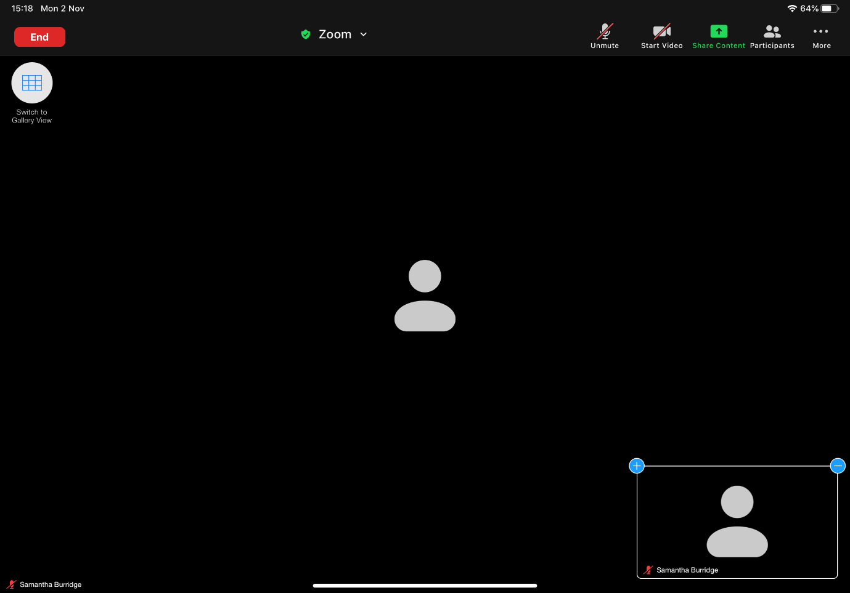

To avoid audio feedback, please mute your microphone unless you are speaking. There will be opportunities for questions during the meeting and if you wish to do so, you will need to unmute your microphone or use the chat function box (details below).

## Phone view:

For the best user experience, it is recommended that you join on a tablet, PC or laptop rather than the mobile phone app, as you can only see 4 participants at a time on screen.

On a phone you will need to swipe between screens from speaker view or to see all participants (gallery view). You can only see a maximum of 4 people per screen.

To mute/ unmute your microphone or show your video/hide your video you need to touch the screen to get the menu to appear and then select the option.

If you click on “participants,” you can view all participants in the call.

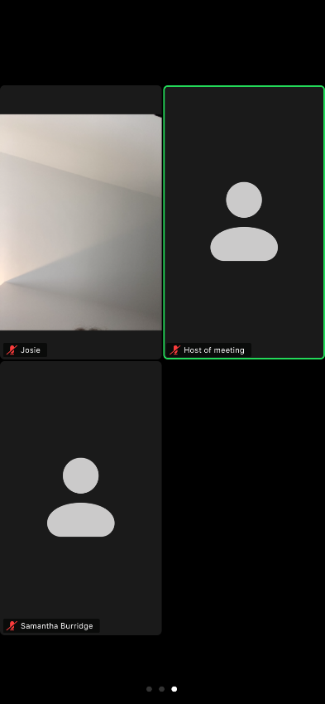 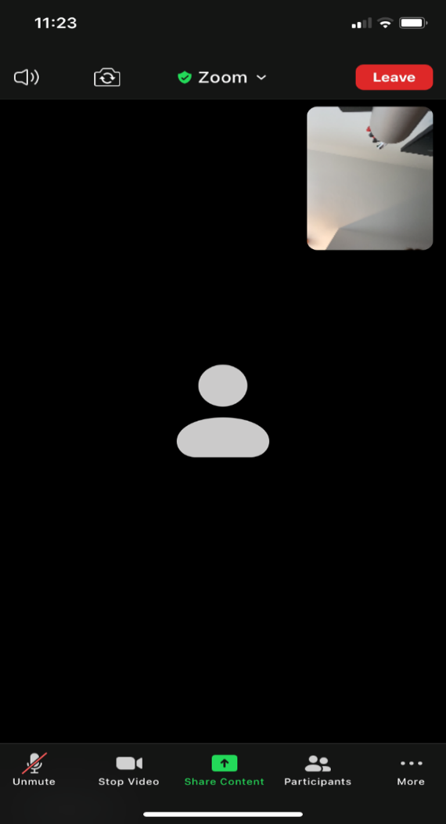

To avoid audio feedback, please mute your microphone unless you are speaking. There will be opportunities for questions during the meeting and if you wish to do so, you will need to unmute your microphone or use the chat function box (details below).

To exit the call, just select “leave,” which is in red at the top right-hand side.

# How to ask a question

There will be opportunities to ask questions on each point of the Agenda.

When the Chair asks if there are any questions you can ask either ask a question in person or by using the chat function.

## Asking a question by speaking at the meeting:

In order to ask a question, you will need to raise your hand via the function in Zoom, this is found:

**In PC view,** by clicking participants along the bottom.

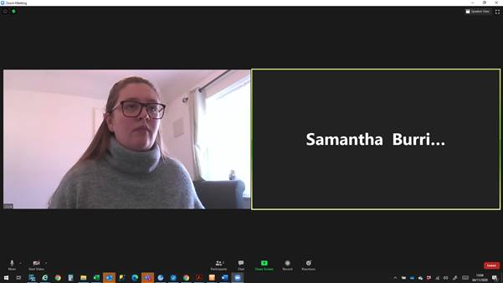

The participants box will then pop up on the right-hand side, and you need to click the three dots in the right-hand corner and click raise hand.

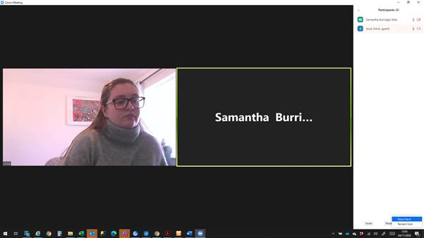

In iPad view, by clicking more and then selecting raise hand.

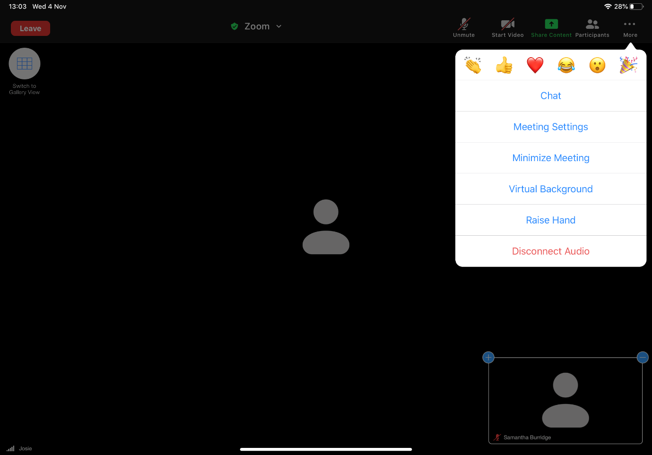

In phone view, by clicking more and then raise hand.

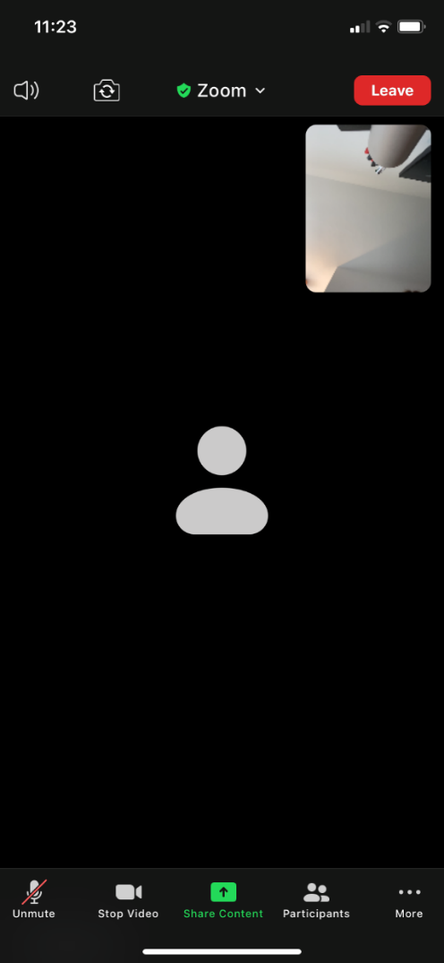 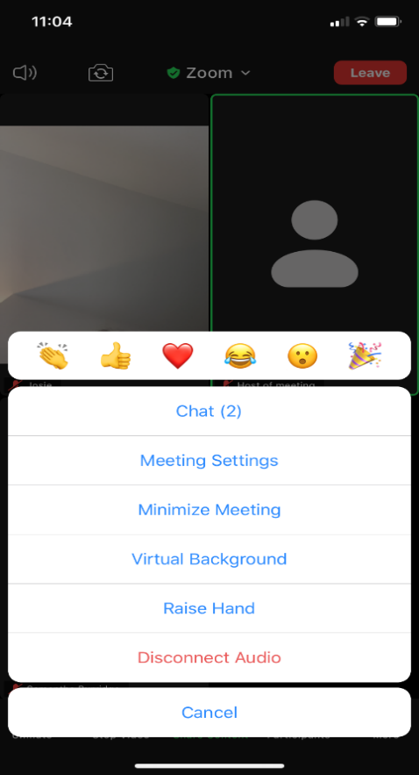

Once you have raised your hand, the Chair will call your name at which point you should unmute your microphone.

To unmute your microphone, click on the microphone icon which is found:

**At the bottom of the screen on desktop view:**



**At the top right-hand side of tablet view:**

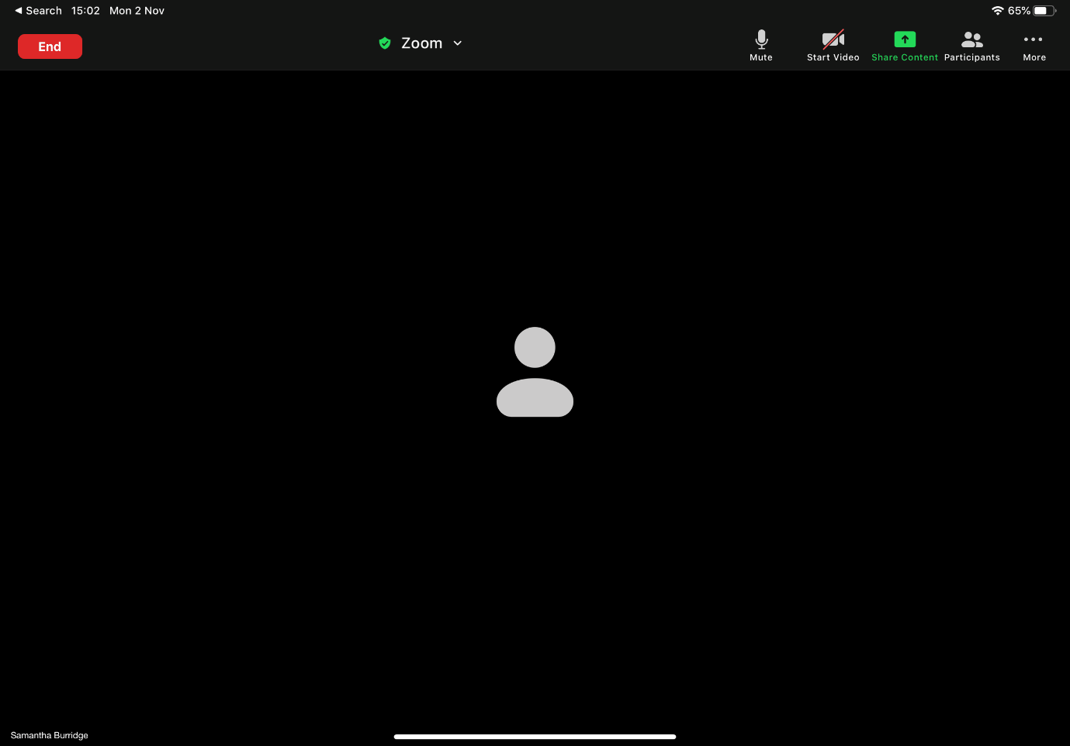

**At the bottom left-hand side of phone view:**



## Asking a question using the chat function:

If you are in PC view, select “chat” along the bottom of the screen and it will pop up on the right-hand side as below. Enter your question in the chat and send.



If you are on a tablet, select more.



The following menu will pop up, click chat.

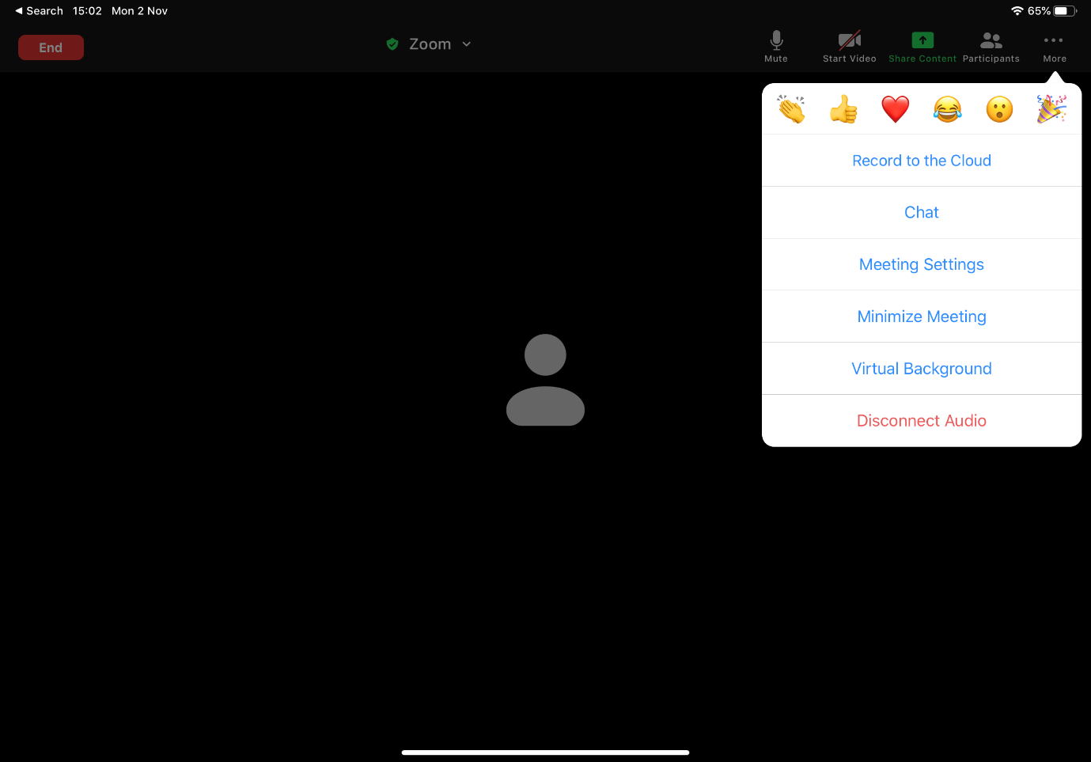

Enter your question in the box and press send

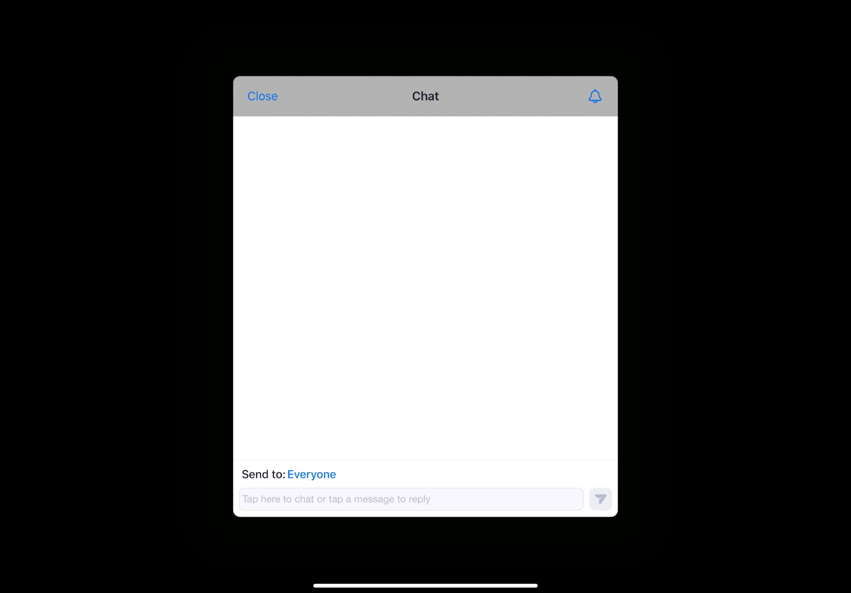

If you are on a phone, select more.

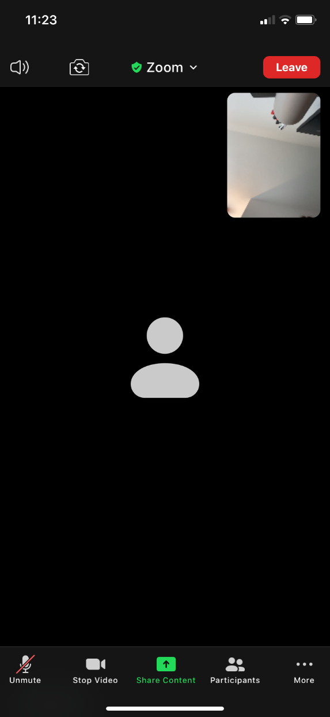

The following menu will pop up, click chat.



Enter your question in the box and press send

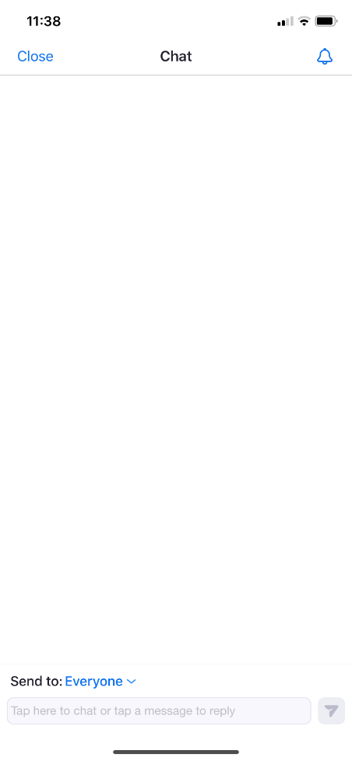

# How to vote

There are three voting items on the agenda. Voting will be completed via a poll, which will pop up on your screen as below.

You will need to select your answer – For or Against – and then hit submit.

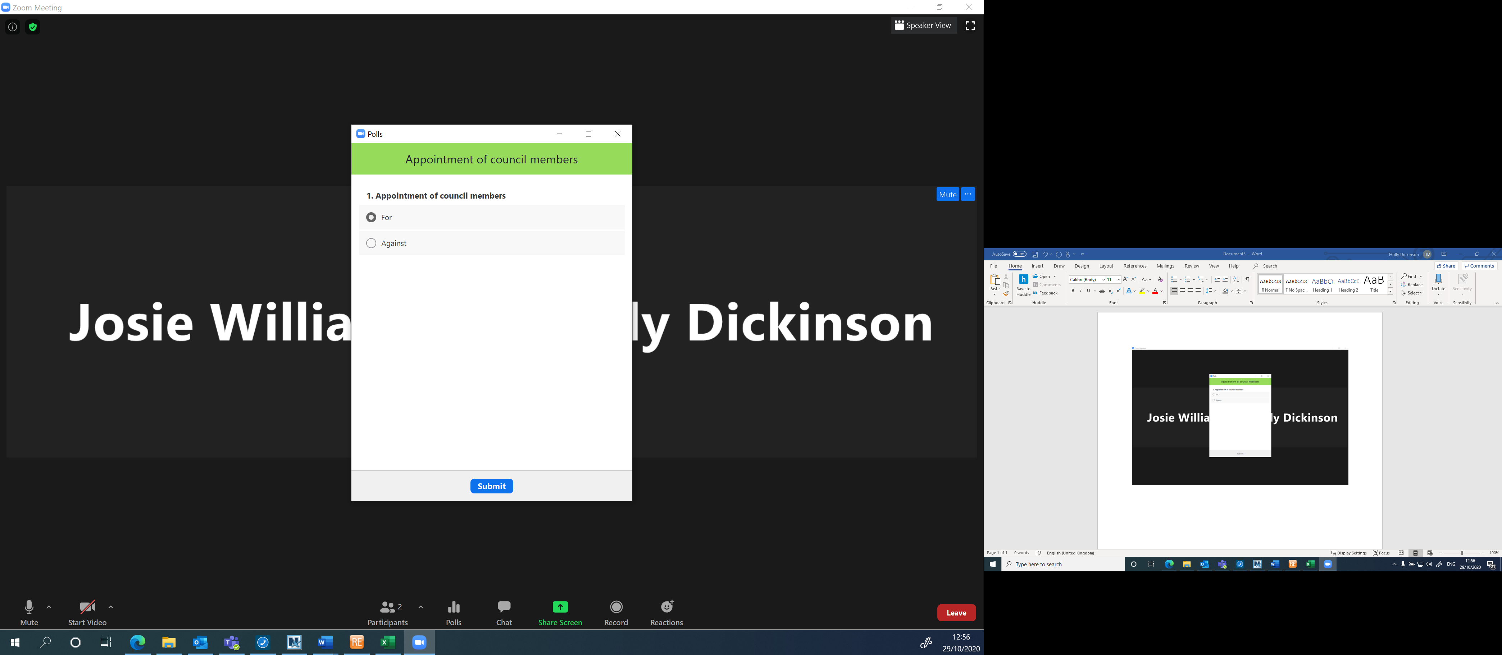

# How to join the lecture

Please click the link below to join the webinar:

<https://us06web.zoom.us/j/89980628564>

Passcode: 869147